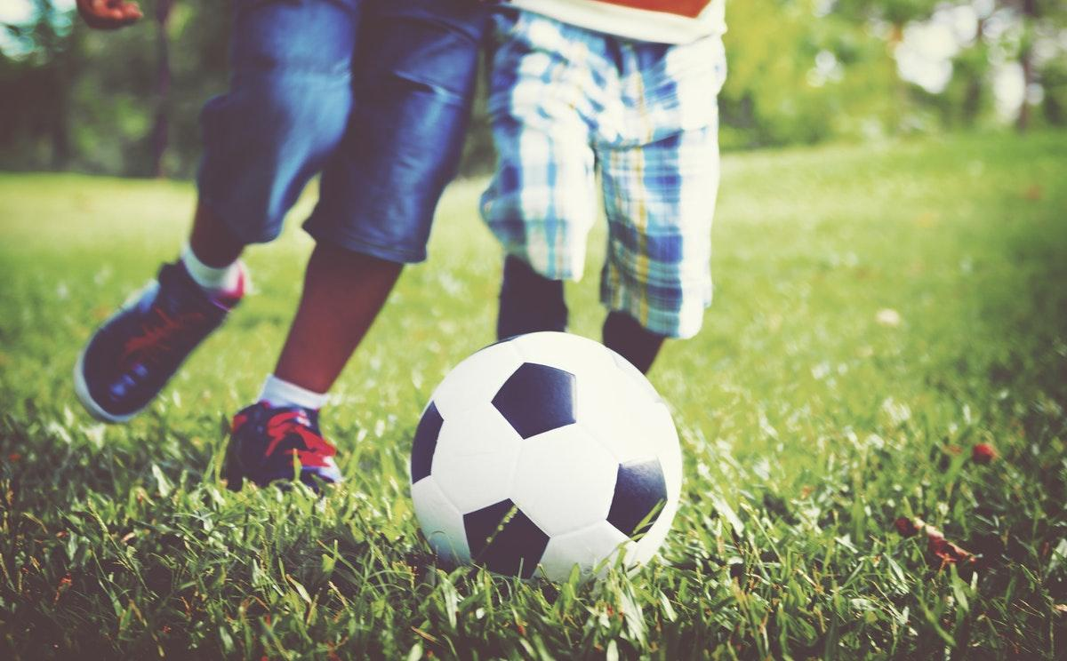

What Parents Should Know About NDD: An Outdoor Activity Guide

Are you worried about nature-deficit disorder affecting your family? If so, then you may be wondering what are the best ways to get your kids outside more often and get them to truly love the outdoors. The answers to those questions can be different depending on your family’s interests, but these are some questions and resources that can help you prevent NDD.

What Outdoor Sports Are Available for Children?

Getting children into sports can be good for their self-esteem, so consider these outdoor options to also prevent nature-deficit disorder.

The Benefits of Sports for Kids
Mountain Biking for Children
Get Kids Interested in Running
Top Outdoor Sports for Kids

What Outdoor Activities are Available in My Backyard?

Consistency is key for preventing NDD, so why not use these tips to foster a love of the outdoors by encouraging kids to spend more time in their own backyard:

How to Install a Playground or Swingset
15 Fun Backyard Ideas for Children
Should You Buy a Swimming Pool?

What Outdoor Activities Are Available in My Community?

Getting your kids out of the house can help grow their love of the great outdoors. So be sure to look for these fun activities in your local community:

Visiting Your Local Farmers Market
Find Parks and Playgrounds Near You
Search for Local Nature Trails

What Clubs and Activities Can Help My Children Get Outside?

Top Scouting Organizations for Kids
Amazing Outdoor Summer Camps for Kids
Outdoorsy Organizations for Your Family

You don’t have to let nature-deficit disorder impact your family, especially when there are so many fun ways to encourage your kids to get outside more often. Whether you want to explore your community or stick to your backyard, there are outdoor activities for your kids and family.

Photo Credit: Rawpixel

